Day 12 – 27th June- 113195064 - Bondili Bhavya Charitha

TASK:1 - What do you understand about data structures?
Data structures are a smart way to store and manage the required data so we can use it easily.
Ex: In toolbox, we have different tools for specific purpose, screwdrivers, hammers etc.

TASK:2 – Types of Data structures and list them out?
- Array – It stores the elements in a contiguous blocks of memory indexed by integers. Ex: My medication box, Sunday to Saturday I have my specific medicines in each small division space which needs to be taken after food.
- Linked List – A collection of nodes, where each node contains the data element and a pointer to next node in order. Ex: It is like a treasure hunt; each clue talks about the next clue.
- Stack – A collection of elements that supports two main operations: Push and Pop. Ex: LIFO method it is.
- Queue – A structure that processes elements in the order they were added. Ex: FIFO Method it is.
- Tree – One root many Branches Ex: My folders on PC, (Respective path C:\Program Files\Java\jdk-23\bin)
- Binary Tree – It’s a tree where each node has most 2 children only commonly left and right child.
- Heap – A specialized binary tree where the parent node is >= / <= its children.
- Graph – A collection of nodes and connections, where each connection connects to 2 nodes. It’s like a social network, everyone’s connected to everyone else (map of relationships).
- Hash Map – It’s a data structure that maps the keys to the values using a hash function. It does addition/deletion/searching several operations.

TASK:3 – What all operations can we do in Data structures?
- Addition: Adding new elements (Push – stack, enqueue – queue)
- Deletion: Removing elements (Pop – stack, dequeue – queue)
- Traversal: Visiting each element (Printing all items in a list)
- Searching: Finding the location of an element
- Sorting: Arranging the elements in a specific order
- Accessing: Retrieving the element at a specific position
- Modifying: Modifying the value of an existing element.

TASK:4 - What are static and dynamic arrays? Explain or summarize key points in a table like Size, performance, memory, flexibility, limitations.
Static Array: These are pre-booked rows in a theatre, once you booked. You’re stuck with the seats.
Dynamic Array: Opposite to Static Array (Array resizes itself automatically during runtime).
Feature | Static Array | Dynamic Array
Size | Fixed | Shrinks
Memory Allocation | Contiguous memory allocated in advance | It will start small and expands as needed
Performance | Faster because its fixed | Slower due to resizing & copying
Flexibility | Less Flexible | Highly Flexible
Limitations | When size is known and won’t change | When size is unknown or varies dynamically
Examples | Int arr[100]; in C | ArrayList in Java, List in Python

TASK:5 - What is the binary value of a?
The Binary value of the lowercase letter a is 01100001.

TASK: 6 - Types of Computer memory with examples?
- RAM: Volatile Memory to store the data – Ex: DDR4, DDR5.
- ROM: Non-Volatile Memory stores the firmware – Ex: BIOS Chip, Firmware on devices.
- Cache Memory: High speed memory between CPU and RAM to speed up data access – Ex: L1, L2 and L3 cache.
- HDD: Magnetic storage for long-term use – Ex: 1TB, HDD.
- SSD: Faster and more reliable than HDD’s – Ex: SATA SSD, NVMe.
- Optical Discs: Use the lasers to write/read the data – Ex: CD, DVD, Blu-Ray Discs.
- Magnetic Tape: Large Capacity – Ex: Data Backup Tapes.
- Cloud Storage: Remote memory accessible via internet – Ex: Google Drive, One Drive.

TASK:7 - Reverse an array. write a code.
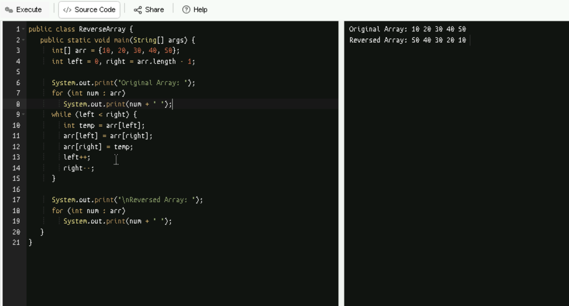

TASK:8 – Reverse a String. Write a code.
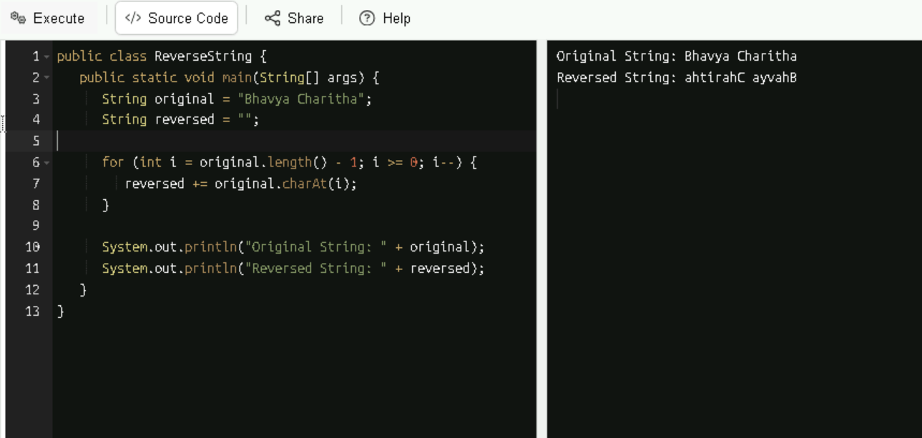
TASK:9 – Leetcode and Hackerrank – Accounts – Done
TASK:10 – What is the code snippet doing?
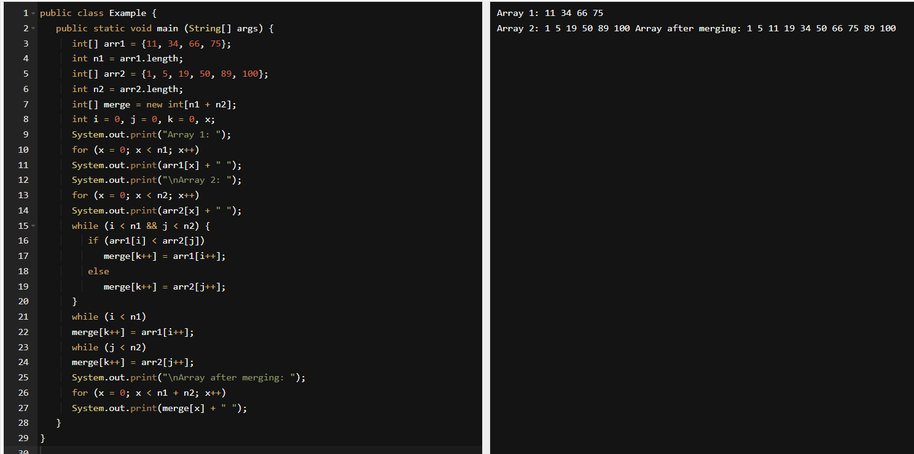
Merging the 2 sorted arrays into one.
Home Work Task: rewrite the code in such a way that it has to take unsorted list and then, merge in an array the sorted list.
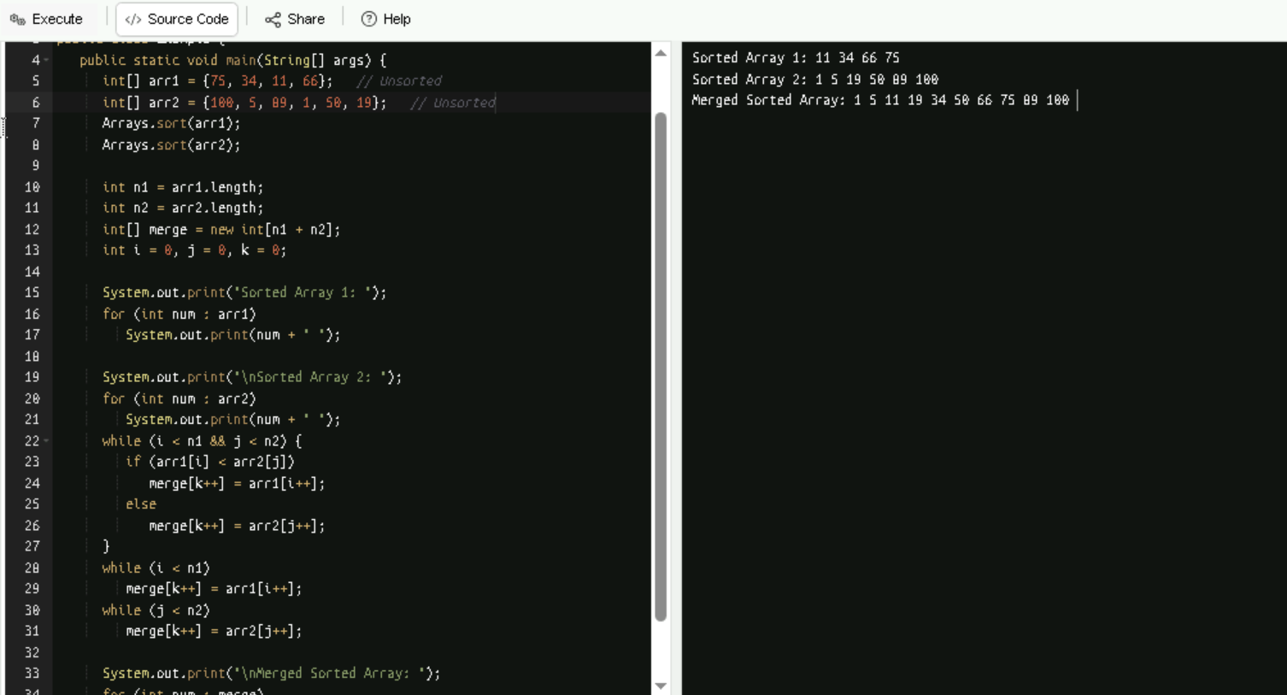

TASK:11 – What do you understand by Hash table?
It is a data structure that stores the main key-value pairs and which allows faster data retrieval using a hash function.
Ex: I want to put my stuff in locker. I handover items and said my name (Key). A wizard (the hash function) turns in to a locker number(index). My stuff (Value) is placed in that locker. Next time, when I say my name again, this wizard hashes it again and I get my stuff instantly. Even if a million people use it, I will still find my stuff in constant time. If 2 people hash the same locker, they can share it (Collision Handling).

TASK:12 – Understand the below Hash table code and try to print values using get method of Hash table.
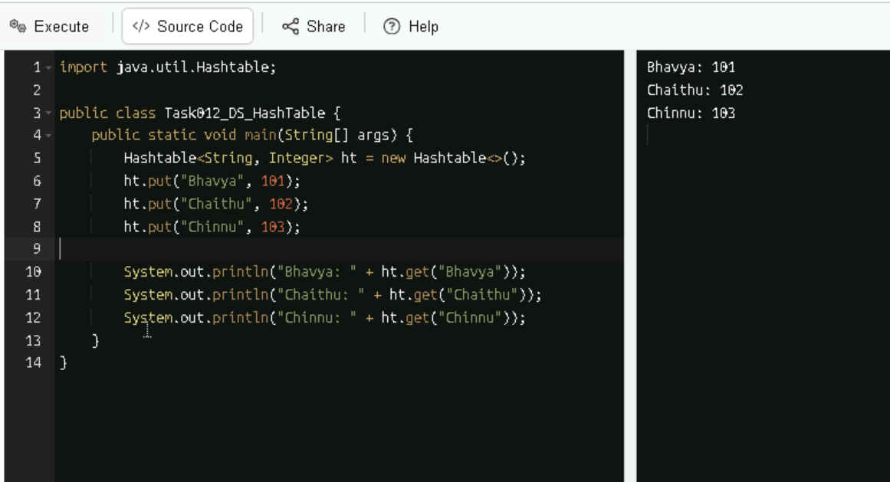
TASK:13 - Hash Map:
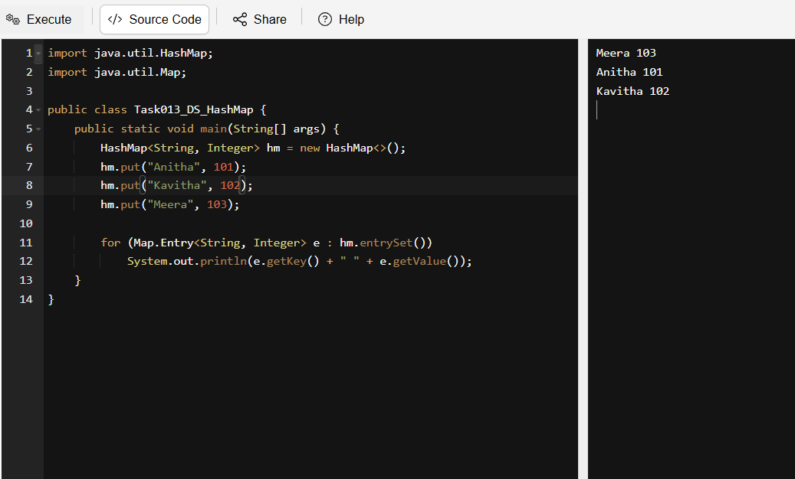

TASK:14 – Difference between Hash Map and Hash Table.
- Hash Table is a Thread – Safe (Synchronized Methods) Hash Map is not a Thread – Safe (Unsynchronized Methods).
- Hash Table is a Slower while Hash Map is a faster.
- Hash table doesn’t allow null key or value and Hash Map allows one null key and multiple null values.
Home Work Task: Hash Table Advantages and Disadvantages:
Advantages:
Faster Access, Flexible Keys, Efficient Addition/Deletion/Modification, used in many real-world applications and Built – In in most languages.
Disadvantages:
No specific order, Collisions, Not memory efficient, Difficult to resize and Poor Case performance.

TASK:15 - Linear Probing in Hash Table
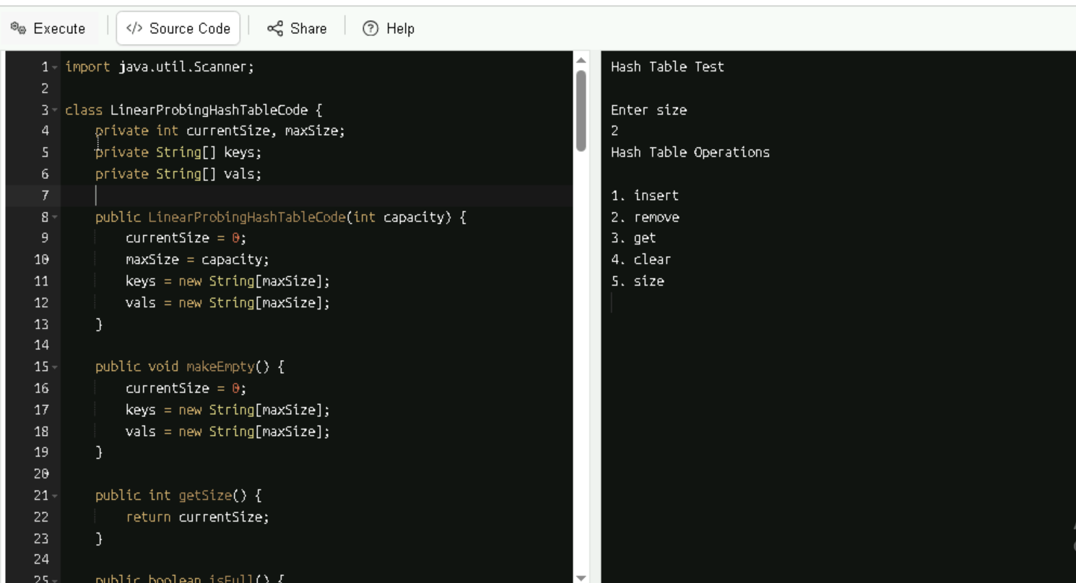

TASK:16 - Try to add 1 null value in the key and run the hash map code. Also add one more null value to the key and see the result.
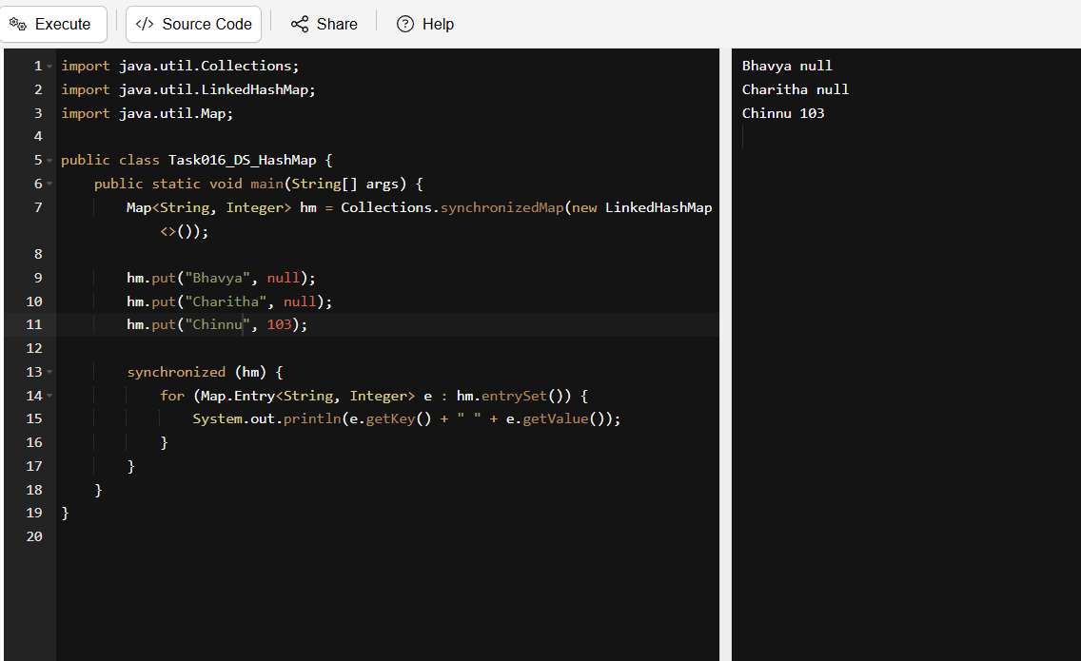
Home Work Task: What is load factor and how the capacity increases?
The load factor is a measure of how full a hash table is allowed to get before it resizes.
Load Factor = No. of Entries / Capacity of Hash Table
How Capacity Increases: When the number of entries exceeds the threshold (i.e., capacity × load factor), the hash table automatically resizes.

Home Work Task: Pointers and load balancing. what are they why are they used and where are they used?
Pointer: A pointer is a variable that stores the memory address of another variable. Instead of holding a value directly, it “points” to where the value is stored in memory.

Why are pointers used:
- For efficient memory access to avoid copying large data.
- In dynamic memory allocation for allocating memory at runtime.
- For data structures which are essential for linked lists, trees, graphs.
- For function arguments as pass by reference.
- In system-level programming for direct hardware access.
Where are pointers used:
- In C/C++ for full pointer support.
- In operating systems for memory management, device drivers.
- In embedded systems for low-level hardware control.
- In game engines for fast memory access for performance.
Load Balancing: It is the process of distributing incoming network traffic across multiple servers to ensure no single server is affected.
Why it is used:
- It improves performance as it prevents server overload.
- It increases availability as if one server fails, others take over.
- It scales easily to add more servers to handle more traffic.
- It optimizes resource use as it keeps all servers working efficiently.
Where is it used:
- In web servers as these distribute user requests across multiple backend servers.
- In cloud computing as the balance workloads across virtual machines.
- In databases as it spread queries across replicas.
- In gaming servers as it handles thousands of concurrent players.

